**BDA:**

**1. To create Employee data with salary in a single table using R.**

# Create a data frame for employee data with salaries

employee_data <- data.frame(

EmployeeID = 1:5,

FirstName = c("John", "Alice", "Bob", "Eva", "Mike"),

LastName = c("Smith", "Johnson", "Wilson", "Davis", "Brown"),

Age = c(28, 32, 25, 29, 35),

Department = c("HR", "Engineering", "Finance", "Marketing", "Sales"),

Salary = c(55000, 65000, 60000, 70000, 58000)

)

# Print the employee data table

print(employee_data)

**2. Define a function in a script, source it to the RStudio and print the multiples of a**

**number.**

print_multiples <- function(num, count) {

multiples <- num * 1:count

cat("Multiples of", num, "up to", count, ":\n")

cat(multiples, sep = ", ")

}

print_multiples(3, 10)

**3. Create two data frames roll no, name, class and other data frame as roll no, subject,**

**marks. Merge this two data frame and print the o/p.**

df1 = data.frame(

rollno = c(1, 2, 3, 4, 5),

Name = c("Paresh", "Liza", "Asmi", "Lucky", "Aastha"),

class = c('A', 'A', 'B', 'B', 'C')

)

df2 = data.frame(

rollno = c(1, 2, 3, 4, 5),

Subject = c("Math", "Science", "English", "History", "Art"),

Marks = c(90, 85, 78, 92, 70)

)

merged_data <- merge(df1, df2, by="rollno")

print(merged_data)

**12. Write a R program to create a Data frames which contain details of 5 employees and display the details.**

df = data.frame(EmpID = c(101, 102, 103, 104, 105),

EmpName = c("Aswin", "Riva", "Tina", "Reva", "Asmita"),

salary = c(20000, 35000, 15000, 45000, 21000),

Age = c(28, 32, 25, 29, 35),

Department = c("HR", "Engineering", "Finance", "Marketing", "Sales")

)

df

**13. Write a R program to create a list of heterogeneous data, which include character, numeric and logical vectors. Print the lists.**

datalist = list(Name = c("Rocky", "Rani", "Reema"),

rollNo = c(21, 23, 35),

pass = c(FALSE, TRUE, TRUE)

)

datalist

**14. Write a R program to create bell curve of a random normal distribution.**

# Set a random seed for reproducibility

set.seed(123)

# Generate random data from a normal distribution

data <- rnorm(1000, mean = 0, sd = 1) # 1000 data points, mean = 0, standard deviation = 1

# Create a histogram to display the bell curve

hist(data, main = "Bell Curve (Normal Distribution)", xlab = "Value", ylab = "Frequency", prob = TRUE, col = "lightblue")

# Add a density curve (bell curve)

curve(dnorm(x, mean = mean(data), sd = sd(data)), col = "red", lwd = 2, add = TRUE)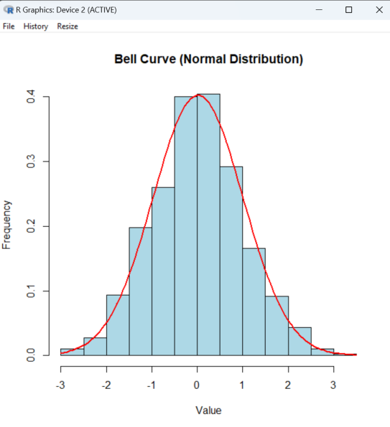

**15. Write a R program to create a simple bar plot of five subjects marks.**

subjects <- c("Math", "Science", "English", "History", "Art")

marks <- c(90, 85, 78, 92, 70)

# Create a bar plot

barplot(marks, names.arg = subjects,

main = "Subject Marks",

xlab = "Subjects",

ylab = "Marks",

col = "blue",

border = "black",

ylim = c(0,100)

)

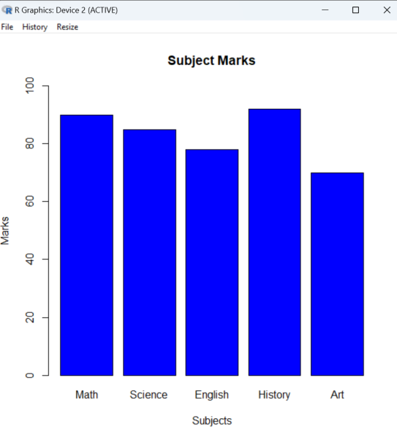

**16. Write a R program to create a 5 × 4 matrix , 3 × 3 matrix with labels and fill the matrix by rows and 2 × 2 matrix with labels and fill the matrix by columns.**

# Create a 5x4 matrix filled by rows

matrix_by_rows <- matrix(1:20, nrow = 5, ncol = 4, byrow = TRUE)

# Create a 3x3 matrix with row and column labels

matrix_with_labels <- matrix(21:29, nrow = 3, ncol = 3,

dimnames = list(c("Row1", "Row2", "Row3"),

c("Col1", "Col2", "Col3"))

)

# Create a 2x2 matrix filled by columns

matrix_by_columns <- matrix(31:34, nrow = 2, ncol = 2)

# Print the matrices

print("Matrix filled by rows:")

print(matrix_by_rows)

print("Matrix with labels:")

print(matrix_with_labels)

print("Matrix filled by columns:")

print(matrix_by_columns)

**17. Write a R program to create a sequence of numbers from 20 to 50 and find the mean of numbers from 20 to 60 and sum of numbers from 51 to 91.**

# Create a sequence of numbers from 20 to 50

sequence_20_to_50 <- 20:50

# Find the mean of numbers from 20 to 60

mean_20_to_60 <- mean(20:60)

# Sum of numbers from 51 to 91

sum_51_to_91 <- sum(51:91)

cat("Sequence from 20 to 50:", sequence_20_to_50, "\n")

cat("Mean of numbers from 20 to 60:", mean_20_to_60, "\n")

cat("Sum of numbers from 51 to 91:", sum_51_to_91, "\n")